### 4.3.5 DATABASE DESIGN

Relationship mapping of each table in a relational database:

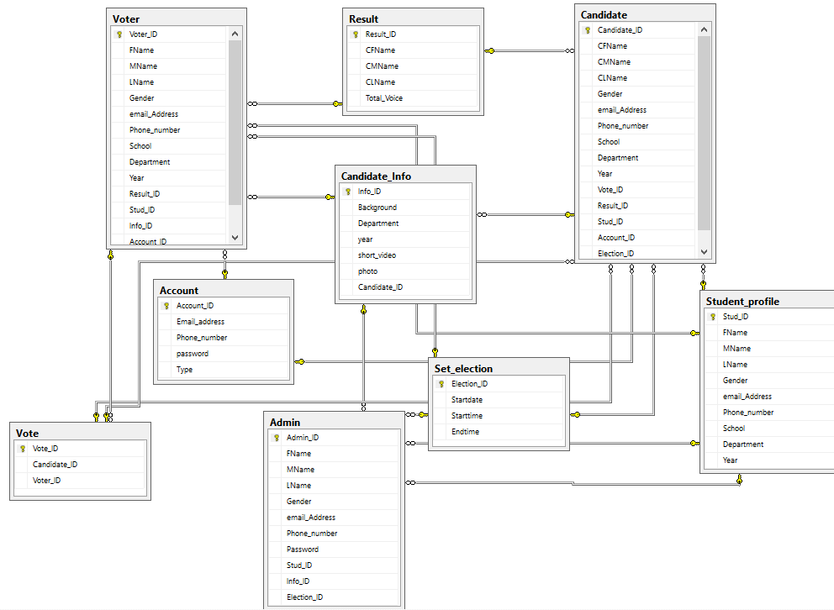

**Figure 32 Database design**